**MidWeek Check:** GotoGro-MRM

**Team Details**

|  |  |
| --- | --- |
| **Team Name:** | MSP 14 |
| **Tutorial:** | Tue 2:30 ATC325 |
| **Tutor:** | Dr Kaberi Naznin |

|  |  |
| --- | --- |
| **Members:** | |
| Dylan Jarvis | 102093138 |
| Rabya Tayal | 103144215 |
| Simon Tran | 103602807 |
| Thomas Babicka | 103059885 |
| Cody Cronin-Sporys | 103610020 |
| Nicholas Dyt | 101624265 |

**Trello Days 1-5**

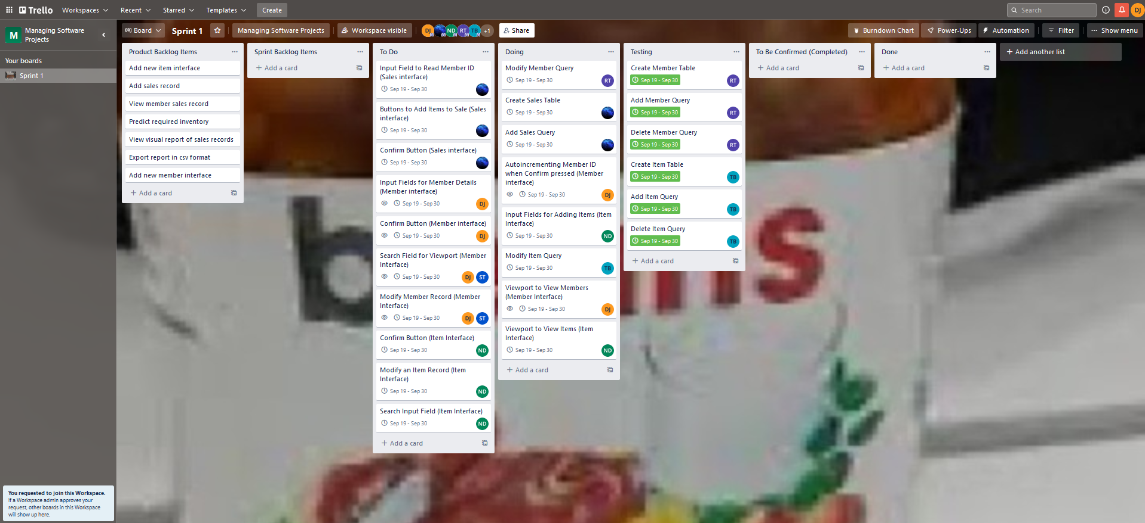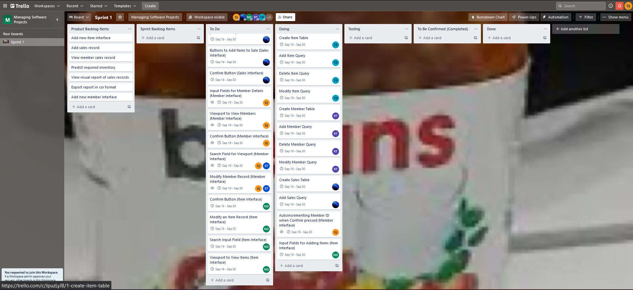There is some overlap with the master document outlining progress, however we were consistent in updating the Trello board to capture ongoing progress.

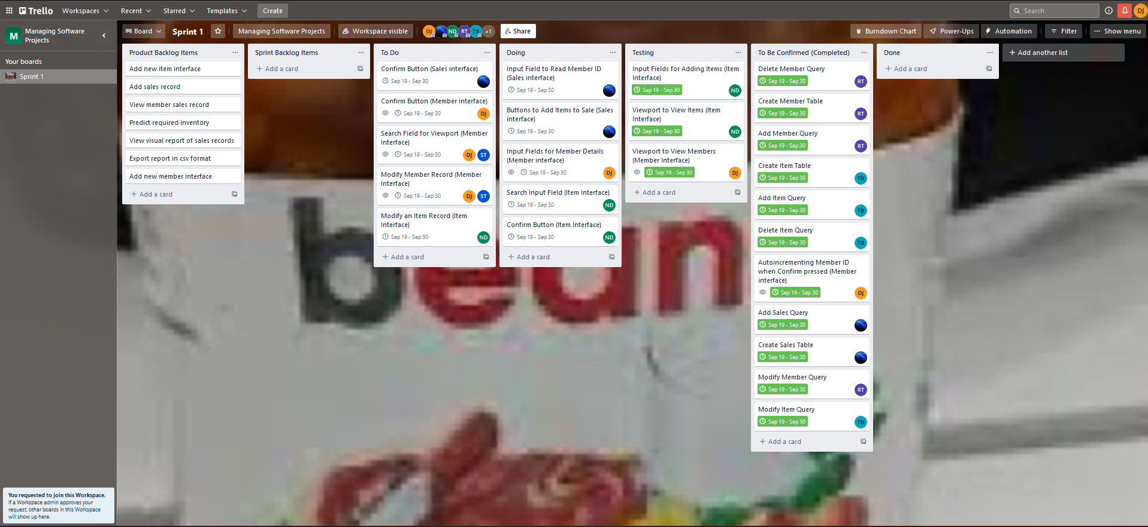

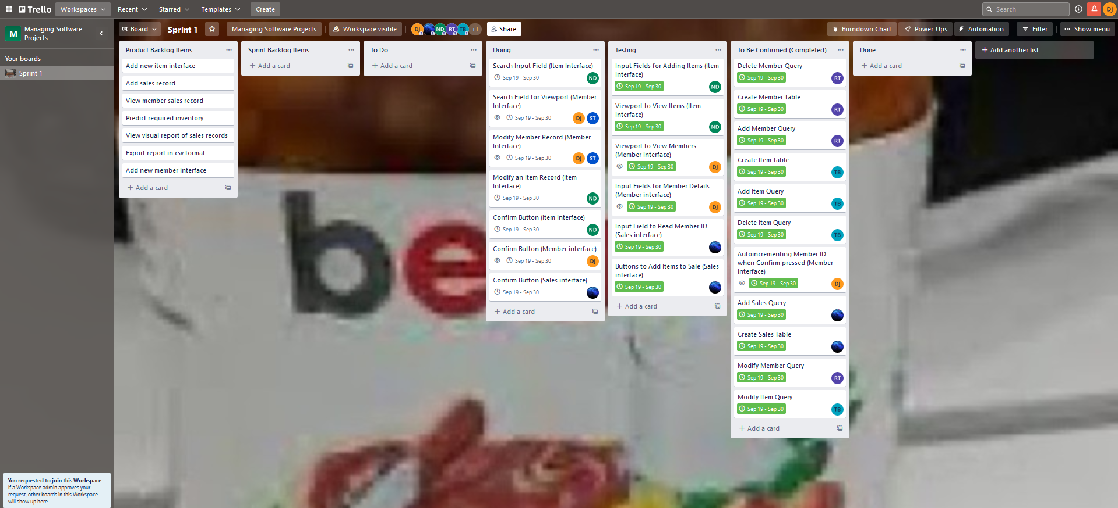

Burndown Chart Days 1-5**

As can be seen from the burndown charts, we are quickly smashing through the tasks allocated for sprint 1 in the product backlog. Though most of the tasks are completed in a single day, there have been a few which haven’t. Ideally these should be split into smaller subtasks, but they are still relatively simple and so we decided against splitting them.

**Group Meeting Notes**